**IMPLEMENTING THE SINGLETON PATTERN**

package singleton;

public class Logger {

private static Logger instance; private Logger() {

System.out.println("Logger instance created.");

}

public static Logger getInstance() {

if (instance == null) {

instance = new Logger(); // Lazy initialization

}

return instance;

}

public void log(String message) {

System.out.println("Log: " + message);

}

}

package singleton;

public class TestSingleton {

public static void main(String[] args) {

Logger logger1 = Logger.getInstance();

Logger logger2 = Logger.getInstance();

logger1.log("First message");

logger2.log("Second message");

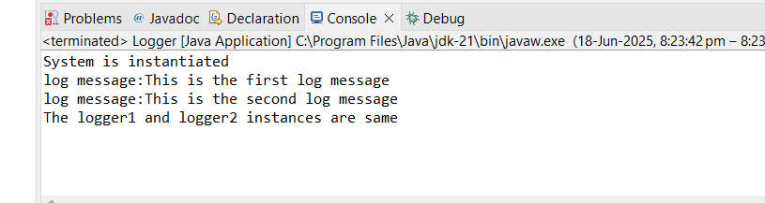

if (logger1 == logger2) {

System.out.println("Both logger instances are the same (Singleton working).");

} else {

System.out.println("Different instances created (Singleton failed).");

}

}

}